# **Unix - Virtual Terminal**

**Linux is a multi-user system**, which allows many users to work on it simultaneously. So what if **different users** need to work **on the same system at a time**? How do you do that? This is where we need the virtual terminals, let us learn about them.

## **What are virtual terminals?**

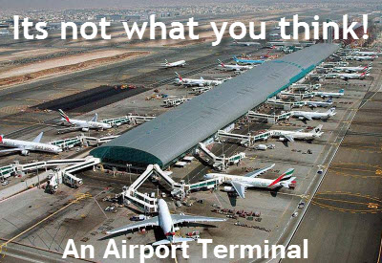

**Virtual Terminals** **are similar to Terminal** that you have been using so far. They are **used for executing commands** and **offering input**. The only difference is that you **cannot use the mouse with the Virtual Terminals**. Therefore, you need to know the keyboard shortcuts.

Virtual Terminals enable a **number of users to work on** **different programs at same time** **on the same computer**. This is the reason they are one of the most **distinguished feature of Linux**.

Let us learn how to access and utilize them.

## **Starting a Virtual terminal**

Usually there are six (default) virtual terminals on a Linux operating system and you can log in to them as different users to conducts different tasks. The steps to launch a Virtual terminal are:

1) Press Ctrl+Alt+F1

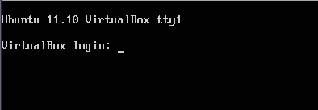

2) Enter User ID and Password

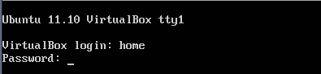

3) Now the Virtual Terminal is ready to work on

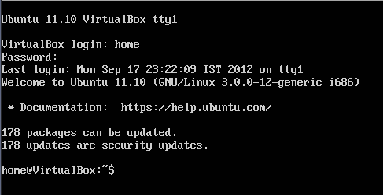

## **Navigating through Virtual Terminals**

You can navigate between the 6 virtual terminals using the following command

***Ctrl + Alt + F (1 to 6) key***

F1 being the first while F6 being the last virtual terminal.

You can work on all of at the same time.

In order to know which virtual terminal you are working on, note **tty** given at the top.

Unix - Virtual Terminal

tty is the teletype number which you can also know by typing the command "tty".

Unix - Virtual Terminal

## **The seventh terminal**

The seventh terminal is the one which we have been using so for in Linux tutorials. It can be accessed by pressing the below given key combination.

**Ctrl + Alt + F7**

### **Virtual Terminal shortcuts**

These are some of the shortcuts that you should be aware of while working on virtual terminals.

|  |  |
| --- | --- |
| **Shortcut** | **Function** |
| Home or Ctrl + a | Move the cursor to the start of the current line |
| End or Ctrl + e | Move the cursor to the end of the current line |
| Tab | Autocomplete commands |
| Ctrl + u | Erase the current line |
| Ctrl + w | Delete the word before the cursor |
| Ctrl + k | Delete the line from the cursor position to the end |
| reset | Reset the terminal |
| history | List of commands executed by the user |
| Arrow up | Scroll up in history and enter to execute |
| Arrow down | Scroll down in history and enter to execute |
| Ctrl + d | Logout from the terminal |
| Ctrl + Alt + Del | Reboot the system |

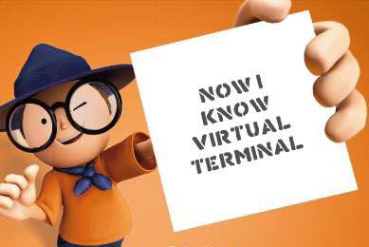

### **Summary:**

* Virtual terminals are CLIs which execute the user commands
* There are six virtual terminals which can be launched using the shortcut keys
* They offer multi-user environment and up to six users can work on them at the same time
* Unlike terminals you cannot use mouse with virtual terminals
* To launch a virtual terminal press Ctrl+Alt+F(1 to 6) on the keyboard
* Use the same command for navigating through the different terminals
* To return to the home screen of the Linux system, use Ctrl+Alt+F7 and it would take to you the terminal